**Task 1: Connecting Two End Devices Using a Hub –** (FromPC-A to Laptop-B**)**

**Steps Followed:**

Our first task was to connect two different types of devices PC-A and Laptop-B to a hub. The goal was to enable communication from PC-A to Laptop-B. To begin with, we proceeded to the End Devices section and selected PC-A and Laptop-B. Having put them on the workspace, we configured the IP addresses and subnet masks for each of the gadgets.

|  |  |  |
| --- | --- | --- |
| Device | IP Address | Subnet Mask |
| PC – A | 192.168.1.1 | 255.255.255.0 |
| Laptop – B | 192.168.1.2 | 255.255.255.0 |
| These values are also clearly visible in the simulation image provided above | | |

Next, we selected one of the Hubs (Hub0) from the list of devices and placed it between the two devices. Then, from the Connections section, we chose the Copper Straight-Through cable to connect the devices to the hub. The reason for using a straight-through cable is that it is used to connect different types of devices, such as PCs or laptops to hubs. After that, we connected PC-A to Hub0 and Laptop-B to Hub0 as shown in the image.

To check whether data could be transferred, we used the Simple PDU tool. We clicked on PC-A as the source device and then on Laptop-B as the destination. After switching to Simulation Mode, we clicked the Play button to start the simulation. The packet successfully reached Laptop-B through the hub, confirming that our network setup and connection were successful.

**Task 2: Connecting Three End Devices Using a Hub –** (FromPC-A to Laptop-C**)**

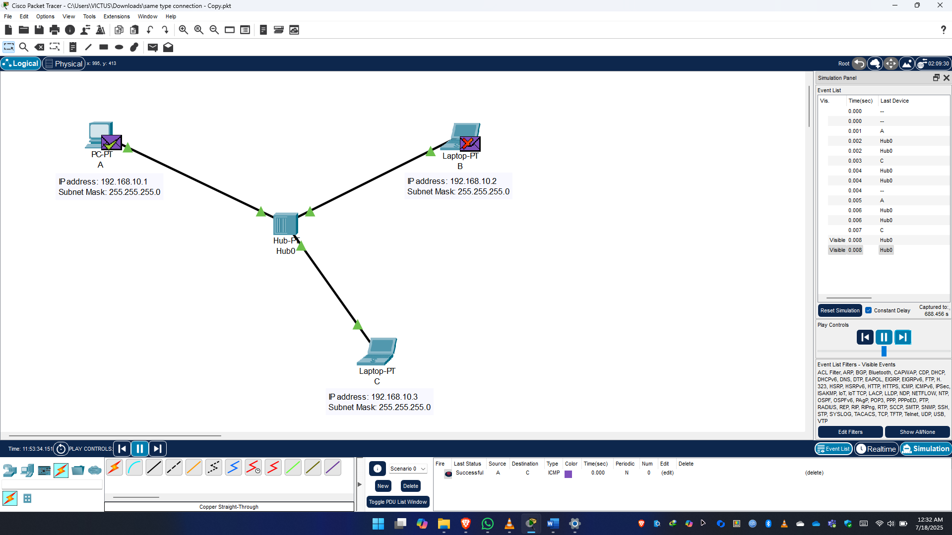

**Steps Followed:**

Our second task was to connect three different types of end devices PC-A, Laptop-B, and a new device, Laptop-C to a hub, and ensure data could be sent from PC-A to Laptop-C. To perform this task, we followed a process like the previous one. We started by keeping PC-A and Laptop-B as they were in the previous task. Then, we selected and added a new device, Laptop-C, from the End Devices list.

After placing the new device in the workspace, we configured the IP addresses and subnet masks for all three devices. The IP configurations were as follows:

|  |  |  |
| --- | --- | --- |
| Device | IP Address | Subnet Mask |
| PC – A | 192.168.1.1 | 255.255.255.0 |
| Laptop – B | 192.168.1.2 | 255.255.255.0 |
| Laptop – C | 192.168.1.3 | 255.255.255.0 |
| These values are also clearly visible in the simulation image provided above | | |

Next, using the Copper Straight-Through cable from the Connections section, we connected all three devices to the hub. As mentioned earlier, a straight-through cable is used when connecting different types of devices such as a PC or laptop to a hub. The connection was completed in the same manner as Task 1.

To test communication, we used the Simple PDU tool. We clicked on PC-A as the source and Laptop-C as the destination. After switching to Simulation Mode, we clicked the Play button to begin the simulation. The packet successfully traveled from PC-A to Laptop-C, indicating that all the connections and configurations were correct and the network was functioning properly.

**Task 3: Two Hubs with Multiple Devices –** (FromPC-A to PC-D**)**

**Steps Followed:**

In the third task, our objective was to use two hubs to build a slightly more complex network. Hub0 was connected to three devices, and Hub1 was connected to two devices. The goal was to send data from PC-A (connected to Hub0) to PC-D (connected to Hub1) through both hubs.

To begin, we added the following devices to our workspace: PC-A, Laptop-B, Laptop-C, PC-D, and Laptop-E. We also added two hubs: Hub0 and Hub1. We then configured the IP addresses and subnet masks for each device. The configurations were:

|  |  |  |
| --- | --- | --- |
| Device | IP Address | Subnet Mask |
| PC – A | 192.168.1.1 | 255.255.255.0 |
| Laptop – B | 192.168.1.2 | 255.255.255.0 |
| Laptop – C | 192.168.1.3 | 255.255.255.0 |
| PC – D | 192.168.1.4 | 255.255.255.0 |
| Laptop – E | 192.168.1.5 | 255.255.255.0 |
| These values are also clearly visible in the simulation image provided above | | |

After setting up the devices, we moved on to the connections. We used Copper Straight-Through cables to connect the devices to their respective hubs, following the same rule that different types of devices use straight cables. However, since we were connecting two hubs (Hub0 and Hub1), which are the same type of device, we used a Copper Cross-Over cable between them. This type of cable is necessary when connecting similar devices.

Once all the connections were made, we tested the network. We used the Simple PDU tool to send data from PC-A (on Hub0) to PC-D (on Hub1). After switching to Simulation Mode and clicking the Play button, we observed that the data packet reached its destination successfully. This confirmed that our entire network setup from IP configuration to cabling was correctly implemented.

**Task 4: Using a Switch to Connect Devices –** (FromPC-A to Laptop-C**)**

**Steps Followed:**

The fourth and final task was to connect multiple devices to a switch instead of a hub. The objective was to test data transfer from PC-A to Laptop-C using a 2960 switch.

To begin, we added three devices: PC-A, Laptop-B, and Laptop-C. We also selected and added a 2960 switch from the Switches section. After placing the devices and the switch on the workspace, we configured the IP addresses and subnet masks as follows:

|  |  |  |
| --- | --- | --- |
| Device | IP Address | Subnet Mask |
| PC – A | 192.168.1.1 | 255.255.255.0 |
| Laptop – B | 192.168.1.2 | 255.255.255.0 |
| Laptop – C | 192.168.1.3 | 255.255.255.0 |
| These values are also clearly visible in the simulation image provided above | | |

To maintain a clean visual structure, we used the Rectangle tool from the Drawing panel to place a box around the switch. This helped to separate the switch visually from other components and simulate an access-limited zone.

Then, we moved on to the connections. Since the devices and the switch are different types of devices, we used Copper Straight-Through cables to connect each of the devices to the switch. The setup looked clean and followed proper networking standards.

To test if data transfer was working, we used the Simple PDU tool and clicked on PC-A as the source and Laptop-C as the destination. After entering Simulation Mode and clicking the Play button, the packet successfully traveled from PC-A to Laptop-C through the switch. This confirmed that the switch-based network was configured correctly and functioning as expected.